**Task 01:** Attach screenshots of the simulated circuits (VDD =10 V & VDD = 20 V) *40 points*

**Task 02:** Attach screenshots of the tables from “Device Parameter Sweep” (VDD =10 V & VDD = 20 V)

*40 points*

**Task 03:** Write your observation from the experiment.

*20 points*

Name & ID: Md. Rifat Ahmed ~ 1931725042

**Task 01:**

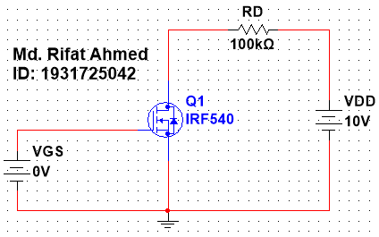

Figure 1: MOSFET Circuit with VDD = 10V

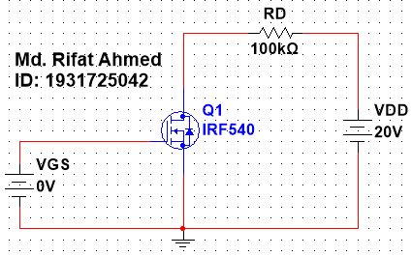

Figure 2: MOSFET Circuit with VDD = 20V

**Task 02:**

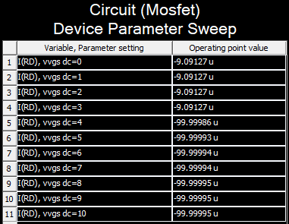

Figure 3: “Device Parameter Sweep” Table for VDD = 10V

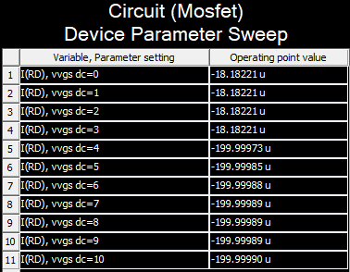

Figure 4: “Device Parameter Sweep” Table for VDD = 20V

**Task 03:**

In this experiment we’ll looking at 2 MOSFET circuits with different VDD and see the difference in their switching characteristics. After building the circuit we took the values of I(RD) using Parameter Sweep. Then we changed the value of VDD to 20V and again took the values of I(RD). Looking at the 1st table we can see that at the beginning until 3V the value of I(RD) is small and constant for VDD = 10V. But from 4V the value of current increases around 10 times and is almost constant until it reaches 10V. Then we see the similar thing happening for the circuit with VDD = 20V from the 2nd table the value of I(RD) is constant at the beginning then jumps to a higher value and again runs almost at a constant current. But one thing that needs to be remembered is that the values are positive even though there’s a negative sign in the figures.